Static website (Project_1)

- Login aws account and lunch instance with name STATIC WEBSITE .
- Os - aws linux ,--> Instance type - t2 micro --> Keypair - xxxxxx -->Security group - Select all traffic --> Ready to lunch instance
- Pem download completed at our local system
- Wait to instance ready state in aws console
- Open putty or mobaxterm (im using mobaxteram)
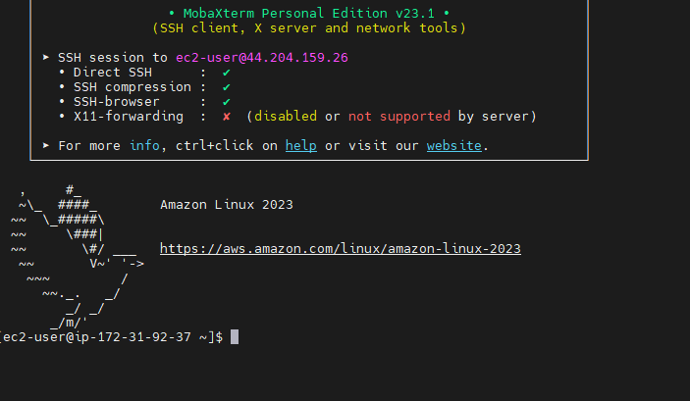

- Change hostname
Sudo hostnamect set-hostname staticwebsite
- change to root user
Sudo -I
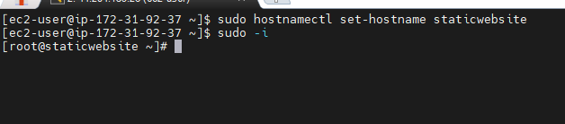

- install apache webserver httpd
Yum install httpd -y
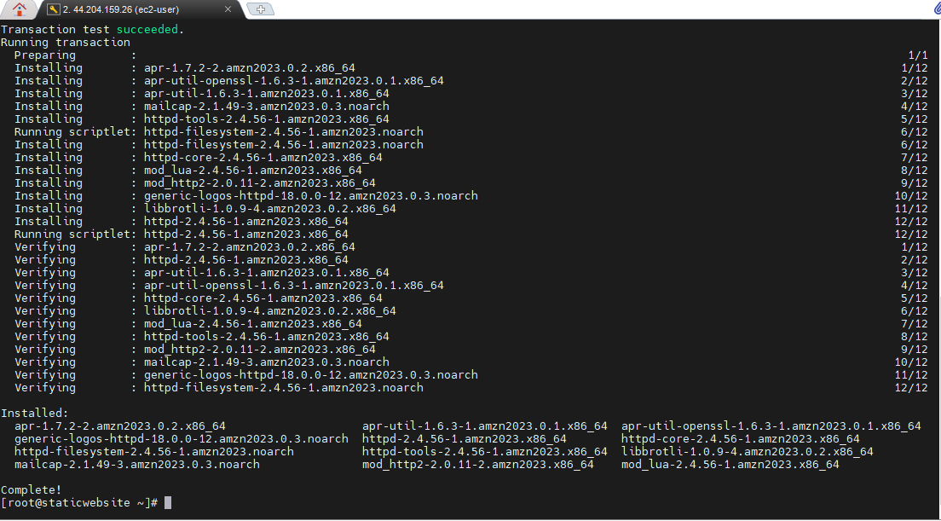

- httpd service start and check status
Systemctl start httpd
Systemctl stats httpd
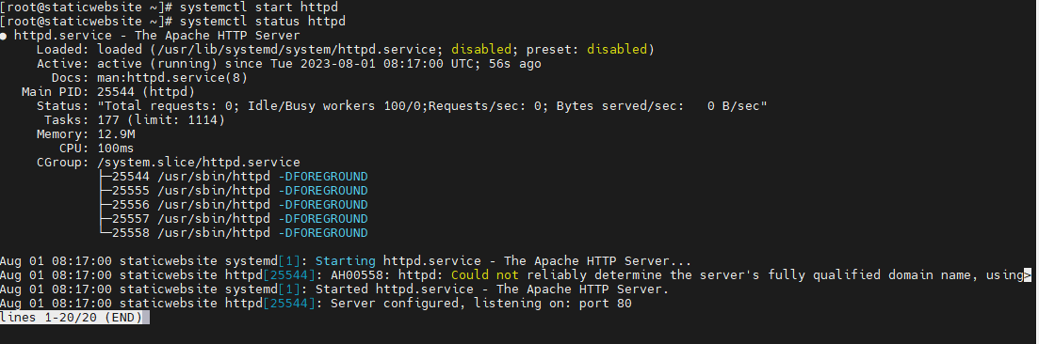

- check public ip address on browser , its working
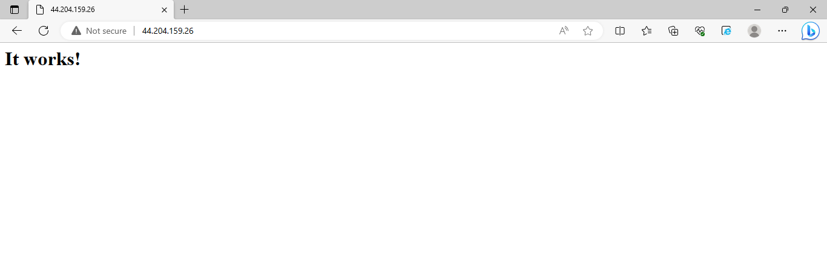

- now go to html directory
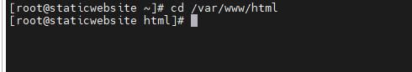

- Now im creating one example html file with name index.html
- In html file write some html script from google
Vi index.html
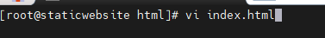

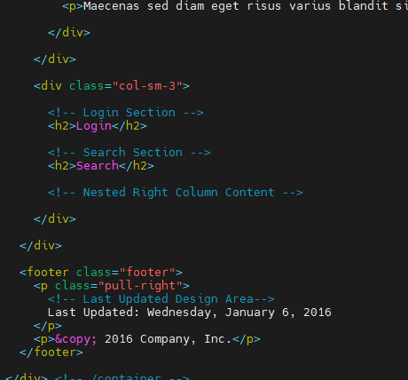

Exit vi editor
Esc+ ;wq!

- now check and refresh the browser
